Entry Guidelines for PAOS City Gallery Exhibition
Who can enter?
Open to all members of PAOS 2016, whether participating in Open Studios or not. Although there will be no selection process for submissions, please ensure you submit your best works to represent PAOS and the Open Studios event to the visitors of the Gallery. The exhibition will run from 23rd June – 6th July with a preview evening on 23rd June. 6pm - 8pm
What to enter
You can enter up to three pieces (jewellery up to six items) of work in total in any of the following media:
Three dimensional work (ceramics, wood sculpture, jewellery, mosaic, metalwork), photography, digital, oil, pencil, pastel, watercolour, acrylic, gouache, textiles, mixed media, glass.
There is an entry fee of £10 per member – to be made on delivery of work, by cash or cheque (payable to Peterborough Artists Open Studios). Work will not be accepted unless payment has been made.
The artwork must be the original work produced by the artist named on the entry form.
Size of work
Maximum size of work: approx. 200cm X 200cm Including frame (no clip frames).
Wall hung work should not project more than 10cm from the frame/canvas. Please attach 2 mirror plates HALFWAY down from the top of the work.
3D work maximum weight: 20 kilos
Maximum base or plinth size: 1 metre on any side.
Artworks, with label/sticker(s) attached on reverse, must be submitted to City Gallery on the dates & times given. On the label you must state artist’s name & title of work.
Delivery & Collection of Work
You will need to drop off your work at the City Gallery on; Saturday 18th & Sunday 19th June between 10am & 3pm
Upon submission you will be given a numbered receipt for your entered work(s). This receipt must be retained as proof of delivery and produced upon collection of the work.
Work cannot be removed until the exhibition closes and must be collected only on the following dates & times: Thursday 7th & Friday 8th July between 10am & 5pm
PLEASE ENSURE YOU ARE ABLE TO DELIVER & COLLECT ON THESE DAYS AND TIMES (or please make arrangements for you work to be collected for you)
Insurance
Risk of damage or loss to the work resides with The Artist until the work is delivered to The Gallery. Once The Gallery takes possession of the work then this risk is transferred to The Gallery and their agents under a nail to nail insurance policy provided that wall-based work be supplied with mirror plates ready to attach to the wall. The Artist is welcome to provide their own insurance for items not able to be secured in this way.
Sale of Work
All works sold are subject to 30% commission + VAT. Please ensure you allow for this when pricing your work. Work sold during the exhibition will not be available until after the exhibition has finished.
For more information/enquiries regarding this exhibition please contact info@paos.org.uk
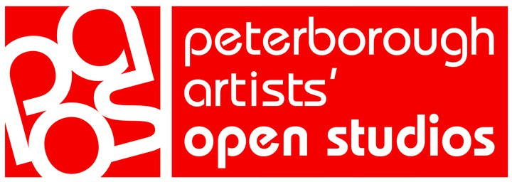
entry form

Personal Details
Please complete and return entry forms to Brochure@paos.org.uk by 10 June 2016
Surname
First name |  | Title:
Address
 |  | Postcode:
Telephone
Email address

Submission Details
No | Title of work | Size | NFS | Cat | Price
1
2
3
All works sold are subject to 30% commission + VAT. Please ensure you allow for this when pricing your work. I have read and accept the entry requirements and certify that this entry is entirely my own work.

Signature ……………………………………………………………………………………………………Date……………………………………………….

Please state Category above: Cat  P - Painting Ph – Photography Pot – Pottery  S – Sculpture Text – Textile D – Drawing  J – Jewellery W – Wood craft MM – Mixed media  M – Mosaics G – Glass Other (please state) | For office use only:

