71. Artist’s Studio £
72. Mobile girls! £
73. Allotments £
CATALOGUE 2019 EE2019
74. Green Light £
75. Pink Rose £
76.
77. Daniel

ART STUDIO
@
THE RED GARAGE

78. Purple Dancers £
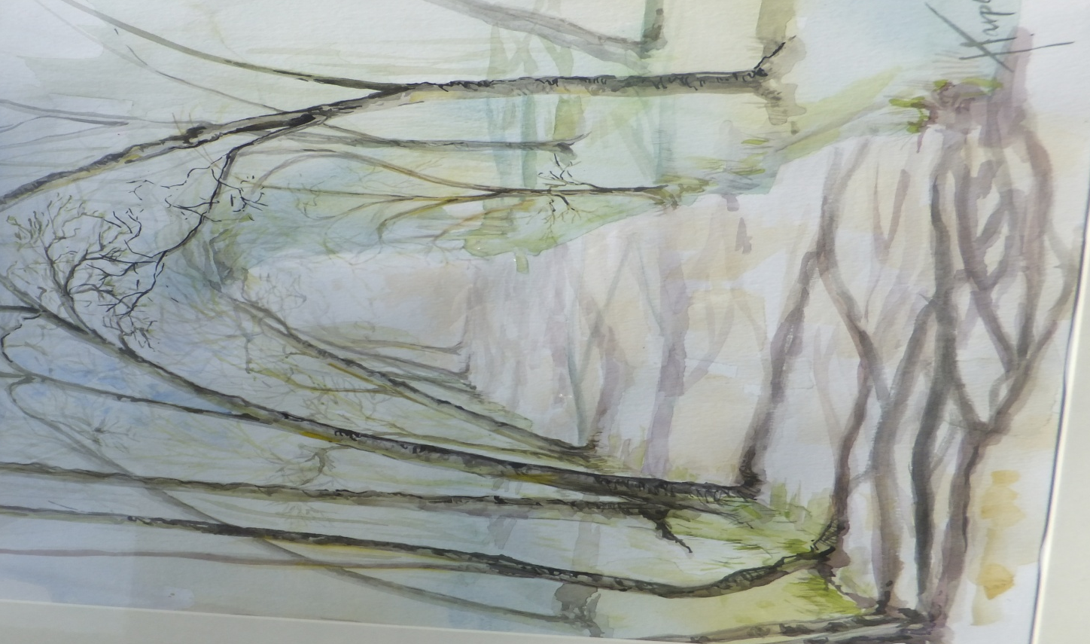
79. Olympic Park [warped] £
80. £
81. Street Fair, Shefford £
82. Circles £
83. £
84. Eye on brown £
85. Boy £
86. £
87. £
88. Nardia. Girl with a sapphire earring £
89.Winter Hellebores £
90. Red £
91. Childhood Splashes £
92. £
93. £
94. £
95. Blueberries with raspberry [framed] £40
96. Nene Park Water £

54, Chapel St. Yaxley.

PE7 3LN 07514322608
sandray.harper@yahoo.co.uk
www.artharper.com
97. Cherries £5
98. The Masai £
99. Tarr steps, Devon
100. £30
101. Autumn Spinney £
102. Masai Women 2
103. Storm approaching. Ferry Meadows £
104. Lines £
Harper
105. £65
106. Clematis
107. Evening on the Devon Coast

- Game Boy £45
- Jenny’s Cove £40
- Tuscany pots £20
- Structure £50
- Straw bear man £25
- You renew the earth [Psalm 104v.30] £150
- Out of the pit [Psalm 103v.4&5] £150
- Fen Flood £
- Lemon slice. “Where’s the gin & tonic?” £
- Late night beach, Snettisham £45
- Wave £150
- Lee Bay, N.Devon [framed] £100
- Kiwi slice £35
- Masai women, Kenya £85
- Lake District [framed] On loan
- Yellow Road, France £35
- Muddy puddle NFS
- Rev. Calixte £60
- ‘Hanging On’ Silver Birch £75
- Snowdrops £50
- Guinea pigs £75
- Joseph. Boy with a jet earring £
- Pollution £50
- Spinney path, Yaxley [watercolour] £20
- Seascape £
- Bamboo, Tuscany villa [ink] £15
- Psalm 96 £80
- Dancers -Energy £
- Shadows, Pound Lane £45
- Daniel. Boy with earring. £
31. Night boat £

32. Spinney at night £
33. Through the tangle £
34. Sea, sky & spray £40
35. ‘Outward looking’. Peterborough Cathedral £
36. Sulehay woods, Wansford £50
37. Hampton Lake £
38. Bluebells £
39. Aqua Flow £40
40. Holme Fen Dyke £
41. Light through branches £
42. ‘What are we looking for?’ £
43. Night trees £
44. Winter Light £
45. Bolt Wins £
46. Wing [red admiral] £
47. Zahra. The girl with an emerald earring. £
48. Jenny's Walk, Devon [watercolour] £
49. North Devon Walk [watercolour] £
50. Ferry Meadows. Autumn [watercolour] £35
51. Cow shed, Bardsey [watercolour] £25
52. Family Wild £
53. The Lakes – an image £250
54. Nardia [framed] priceless
55. Zahra [framed] priceless
56. In St. Peter's £60
57. Swan. Yaxley Dyke £60
58. Frosted On loan
59. Flood at Ferry Meadows [print] £30
60. Iris £25
61. Spinney at Night £
62. Sulehay Woods, Wandsford [watercolour] £
63. Cathedral Forest £200
64. Sophia with a sparkly hat priceless
65. Bardsey sky, Irish Sea £60
66. Bardsey fields, Irish Sea £60
67. Marakesh [street 1] £35
68. Marakesh [street 2] £35
69. Marakesh [street 3] £35
70. Marakesh scarf market £40

Oil painting was one of the subjects I studied at Canterbury College whilst training to be a teacher. In 2010 I started oil painting again and at every opportunity I have a paintbrush in my hand: it has become an important part of my life. Inspiration comes from a wide range of sources and I'm continually exploring content, size, technique and style. I've had 3 small exhibitions in Bedfordshire and belong to Open Studios in Peterborough. During this last year I've been focusing on portraits and the significance of vivid texts as found in the Psalms.
All paintings are in oils unless otherwise stated.

