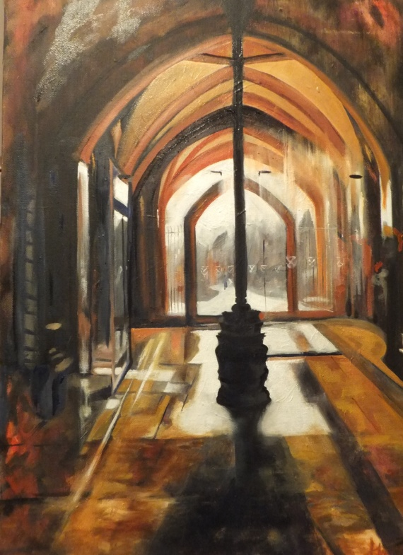
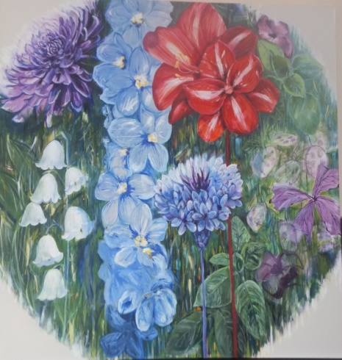
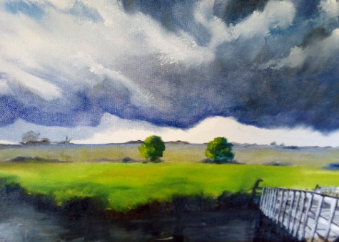
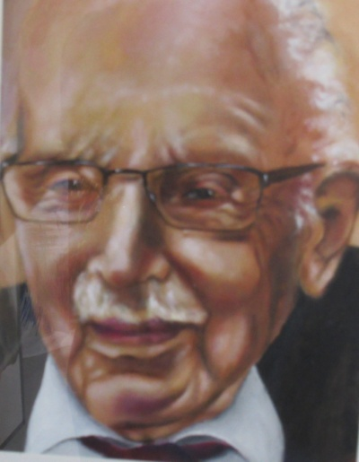
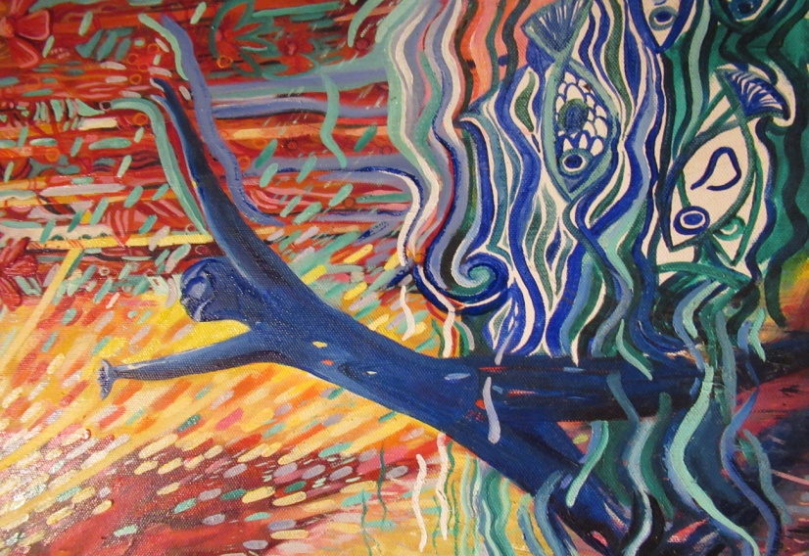
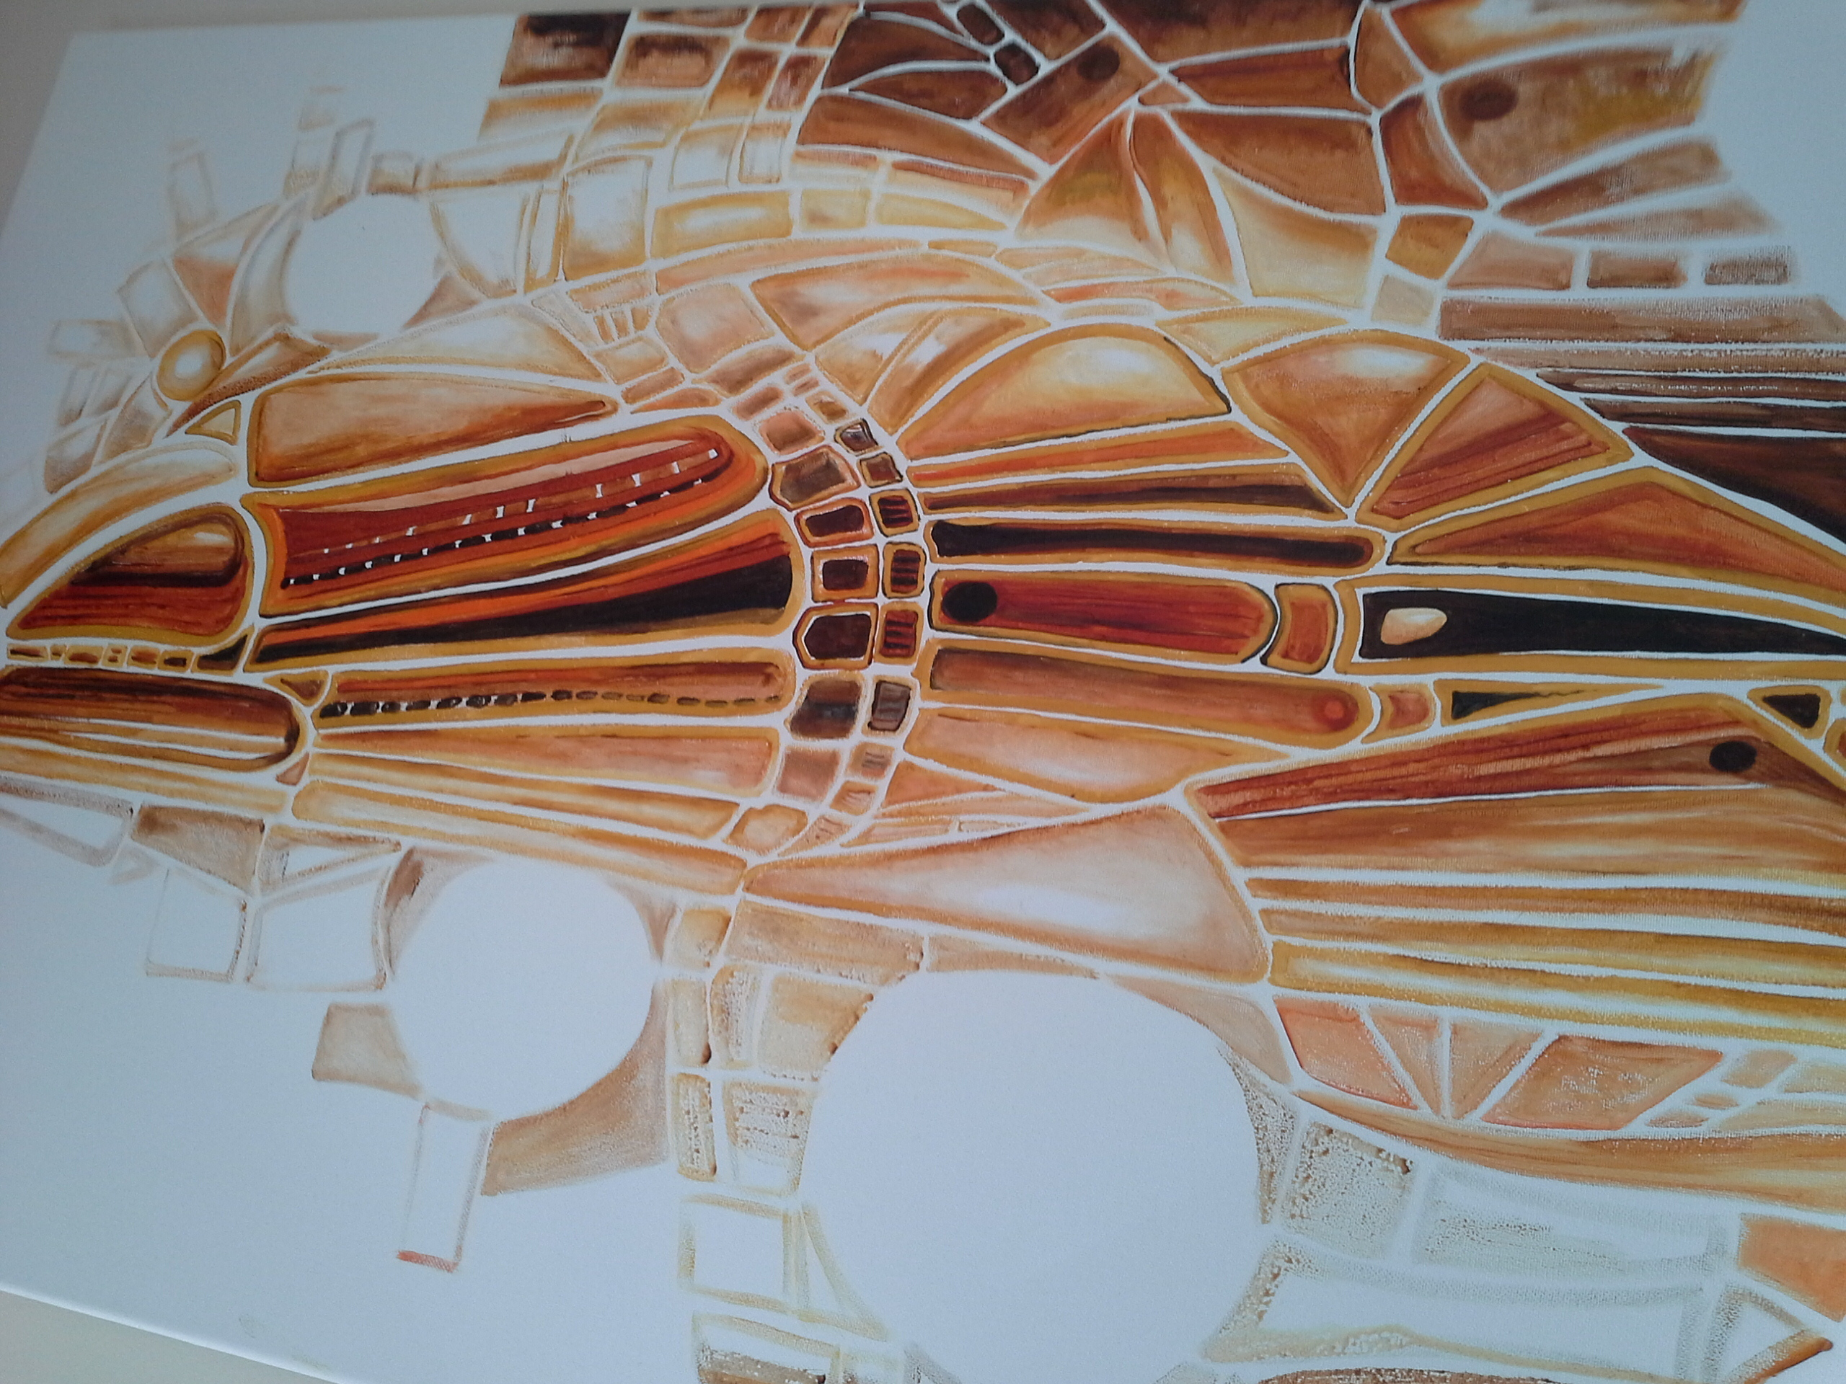
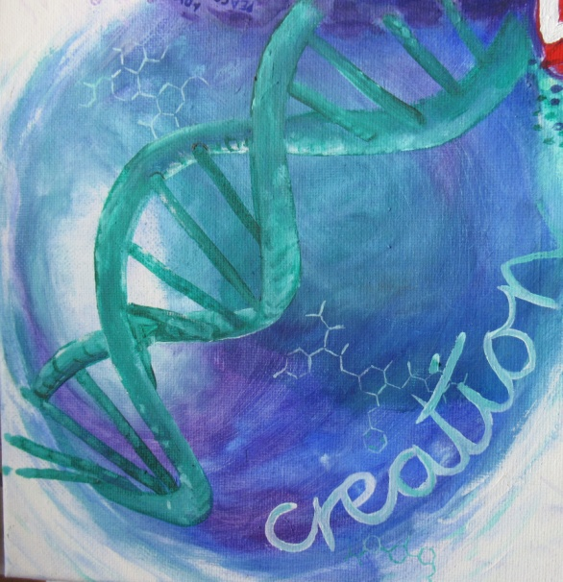
Solo exhibition Sy Harper www.artharper.com 07514322608
Harper
FINE ART EXHIBITION
STAMFORD ARTS CENTRE PE9 2DL

6th – 17th SEPT. 2022

SHADES OF PASSION PAINTING IN OILS
a mix of styles & subjects

